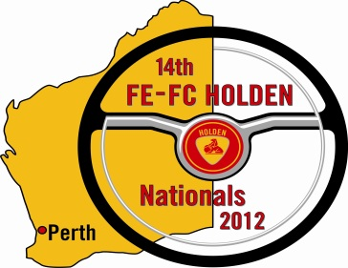 | MERCHANDISE FORM  14TH FE-FC HOLDEN NATIONALS  PERTH, WA, EASTER (APRIL 6-9th) 2012  Hosted by the FE-FC Holden Car Club of WA  Entries Close 31st January 2012  Office Use (Entry Nº : ) |  |  | 
Merchandise Item |  | Size | Total Quantity |  | Price | Total
Example Shirt |  | XL | 2 |  | x $20.00 | $40.00
Additional FE-FC 14th Nationals Entrant T-Shirt |  |  |  |  | x $20.00 | $
FE-FC 14th Nationals Polo Shirt |  |  |  |  | x $35.00 | $
FE-FC 14th Nationals Polar Fleece Vest |  |  |  |  | x $35.00 | $
FE-FC 14th Nationals Cap (one size fit most) |  |  |  |  | x $15.00 | $
FE-FC 14th Nationals Hat Badge |  |  |  |  | x $8.00 | $
FE-FC 14th Nationals Stubby Holder |  |  |  |  | x $8.00 | $
 |  |  | Merchandise Total: |  |  | $
Entrant Information:

Entrant Payment and Communication Detail with FE-FC Holden Car Club of WA
Payment is to be by Cheque, Money Order or Direct Deposit to: FE-FC Holden Car Club of WA. Account details are:
Bendigo Bank BSB: 633 – 000 Account: 140145129 A/c Name: FE-FC Holden Car Club of WA.
(If you make a Direct Deposit payment, make sure you add ‘Nats your initial surname & state’ listed above as the customer reference on the Direct Deposit form, so we know it come from you. An example custumer reference would be ‘NATS C JONES WA’) If you need further details, please check out the website – www.fefcholden .org.au/nats – or email to luckyfc@bigpond.com – or phone/sms: Damien on 0416 171 798
Name: |  |  |  |  | Phone (H):
Address: |  |  |  |  | (W):
Suburb: |  | State: |  |  | (M):
 |  |  |  |  | P’Code:

Payment Option:

Cheque/Money Order
Direct Deposit & Receipt No:

Payment method:

SIZE: Standard shirt sizes apply XS to 3XL Men, and 8 to 24 Ladies.
NOTE: Entrant ‘Goodie bag’ will contain FE-FC 14th Nationals Entrant T-shirt & FE-FC 14th Nationals Hat Badge. A small amount of official merchandise will be available at the event, but it is recommended that you pre-order to avoid disappointment and ensure you obtain clothing in the correct sizes. Pictures of Merchandise will be available on Nats website - www.fefcholden.org.au/nats in due course.

